**Introduction to Javascript**

**1.Prompt for amount, interest rate and no. of years and calculate simple interest.**

**Ans-**

<!DOCTYPE html>

<html>

<head>

<title>Simple Interest</title>

</head>

<script>

function mysi()

{

var p,r,t;

p=prompt("Please Enter Principle Amount");

r=prompt("Please Enter Rate Amount");

t=prompt("Please Enter Time");

var si=(p*r*t)/100;

document.write("Simple Interest (calculated anually) is: "+si);

}

</script>

<body>

<center>

<input type="button" value="Calculate the simple interest" onclick="mysi()" />

</center>

</body>

</html>

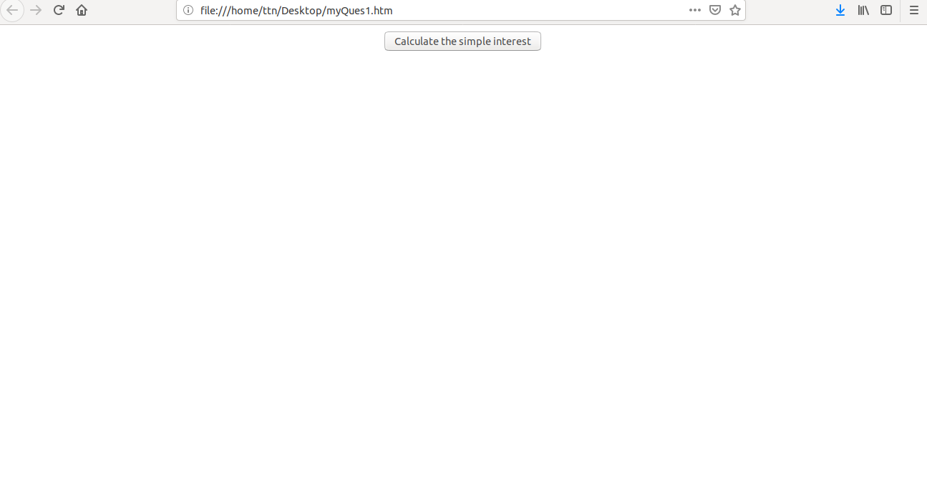

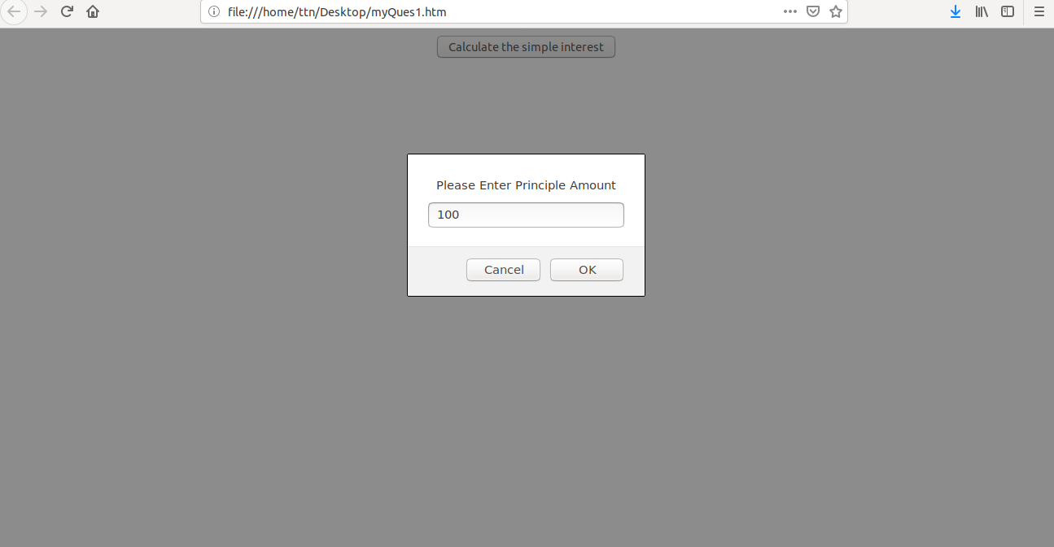

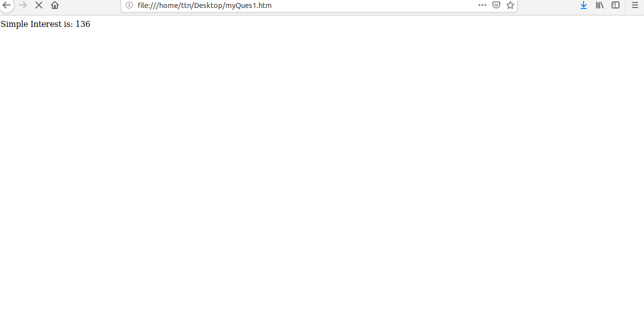

**2. is palindrome string**

**ANS-**

<!DOCTYPE HTML>

<html>

<head>

<script>

function checkpel(){

var a = document.getElementById('mystring').value;

var s='';

var i='';

var j=a.length;

for(i=j-1;i>=0;i--){

s+=a.charAt(i);

}

if(s==a){

document.getElementById('results').value="it is a palindrome";

}else{

document.getElementById('results').value="it is not palindrome";

}

}

</script>

</head>

<body>

<div>

<h2>Palindrome question </h2><br>

Enter the String: <input type="text" value="." id="mystring"><br><br>

<button onClick ="checkpel()">Check</button><br><br><br>

Results: <input type="text" value="." id="results">

</div>

</body>

</html>

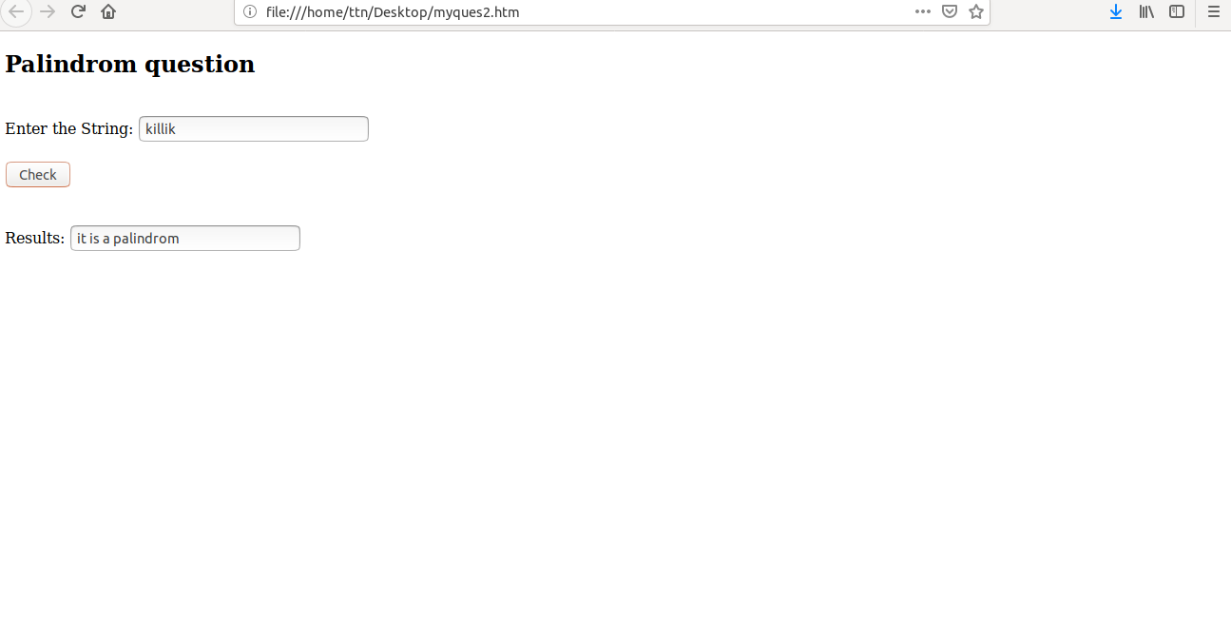

**3. Area of circle**

**Ans-** <!DOCTYPE HTML>

<html>

<head>

<script>

function areaCircle(radius){

var radius = Number(document.getElementById('radius').value);

var areaCircle = Math.PI * radius * radius;

document.getElementById('results').value = areaCircle.toFixed(3);

}

</script>

</head>

<body>

<div>

<h2> Area of Circle: </h2><br>

Enter the Radius: <input type="text" value="0" id="radius"><br><br>

<button onClick ="areaCircle()">Calculate area</button><br><br><br>

Results: <input type="text" value="0" id="results">

</div>

</body>

</html>

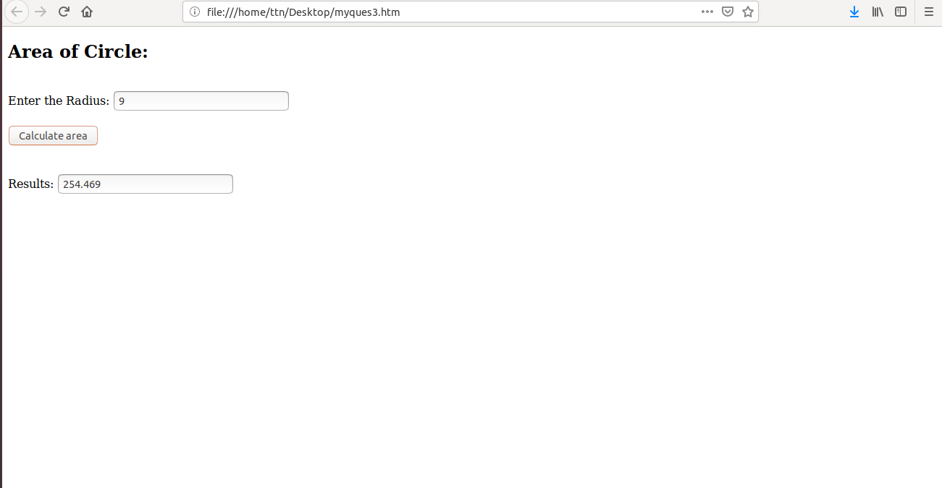

**4.Copy information of one object to another and log it to console.**

**Ans-** <!DOCTYPE HTML>

<html>

<head>

<title>Copy object</title>

</head>

<body>

<h2>Here is second object</h2><br>

<script>

var ob1={id:1,name:"kumar"};

var ob2=Object.assign(ob1);

document.write(JSON.stringify(ob2));

console.log(JSON.stringify(ob2));

</script>

</body>

</html>

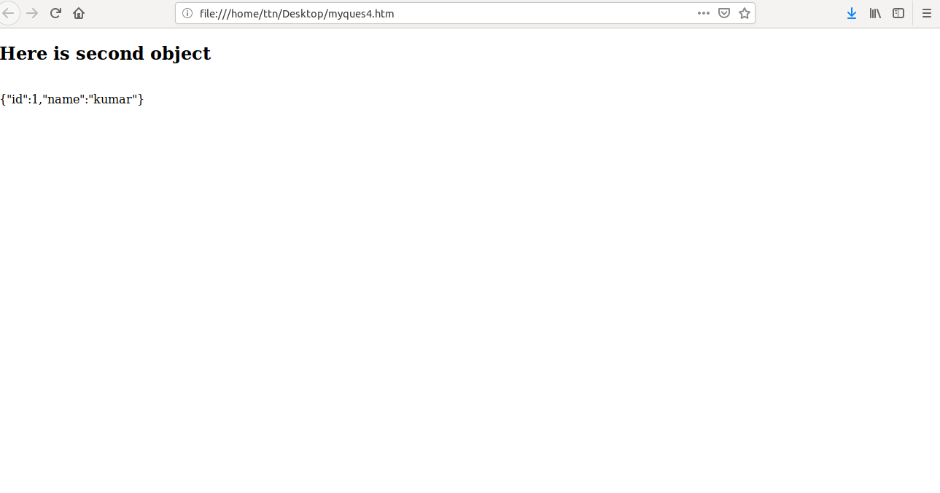

**5. create a list of objects of Employee with info as follow :**

* **Name, age, salary ,DOB**
* **filter all employees with salary greater than 5000**
* **group employee on the basis of their age**
* **fetch employees with salary less than 1000 and age greater than 20. Then give them an increment 5 times their salary.**

**Ans-**

<!DOCTYPE HTML>

<html>

<head>

<title>employee list</title>

</head>

<body>

<pre id="test"></pre>

<script>

var employees=[

{ name:'kumar',age:19,salary:3000,DOB:'12-12-1999'},

{ name:'Shri',age:21,salary:4000,DOB:'24-10-1997'},

{ name:'Lily',age:21,salary:900,DOB:'15-03-1997'},

{ name:'somesh',age:24,salary:15000,DOB:'22-04-1996'}

];

employees.forEach(

function(e){

document.write(JSON.stringify(e)+"<br>");

});

document.write("<br> Employees whose salary is bigger than 5000");

i=0;

employees.forEach(

function(e){

if(e.salary>=5000){

i++;

document.write("<br>"+e.name+"-"+e.salary+"<br>");

}

});

document.write("<br> fetch employees with salary less than 1000 and age greater than 20. Then give them an increment 5 times their salary");

i=0;

employees.forEach(

function(e){

if(e.salary<1000 && e.age>20){

i++;

document.write("<br>"+e.name+"-"+e.salary+"<br>");

}

});

document.write("<br> Increment it by 5 times");

i=0;

employees.forEach(

function(e){

if(e.salary<1000 && e.age>20){

i++;

e.salary*=5;

document.write("<br>"+e.name+"-"+e.salary+"<br>");

}

});

document.write("<br> Group employee by age:");

Array.prototype.groupBy = function(prop) {

return this.reduce(function(groups, item) {

const val = item[prop]

groups[val] = groups[val] || []

groups[val].push(item)

return groups

}, {})

};

const groupByMake = employees.groupBy('age');

document.write("<br> Group employee by age:"+groupByMake);

</script>

</body>

</html>

